EDGE INTELLIGENCE
LAB - 4

25MML0046
GOWTHAM V
TASK 1: ARTIFICIAL NEURAL NETWORK USING DL

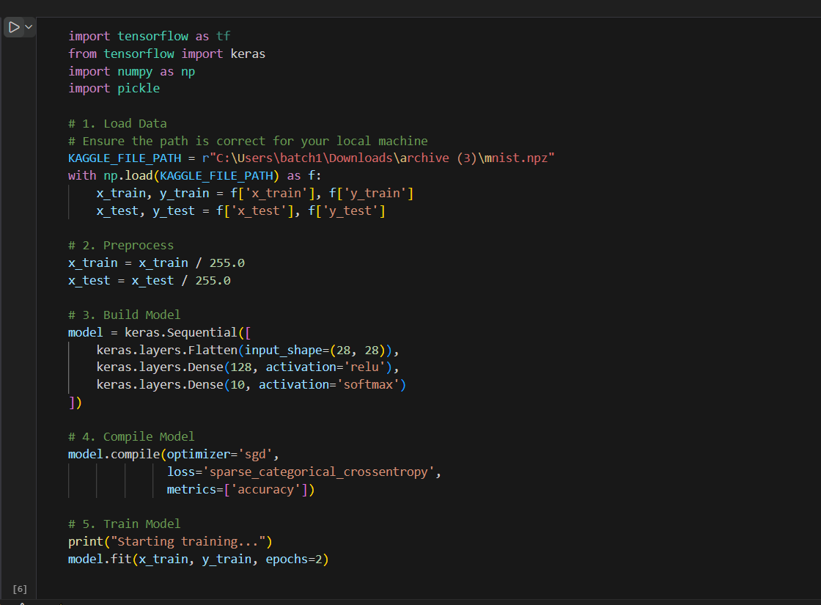
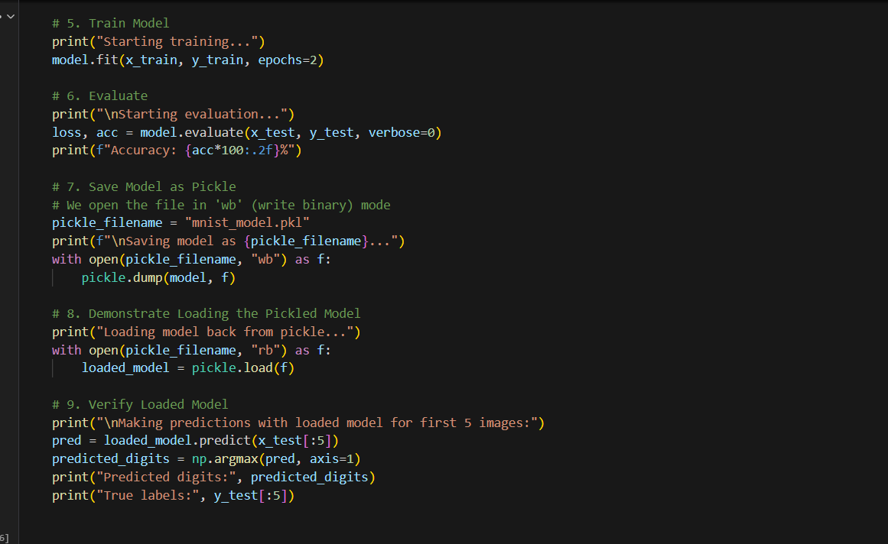

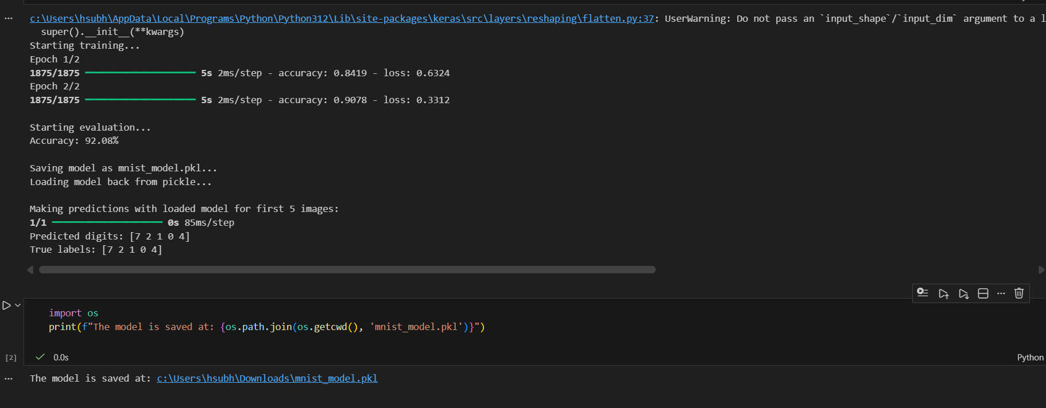

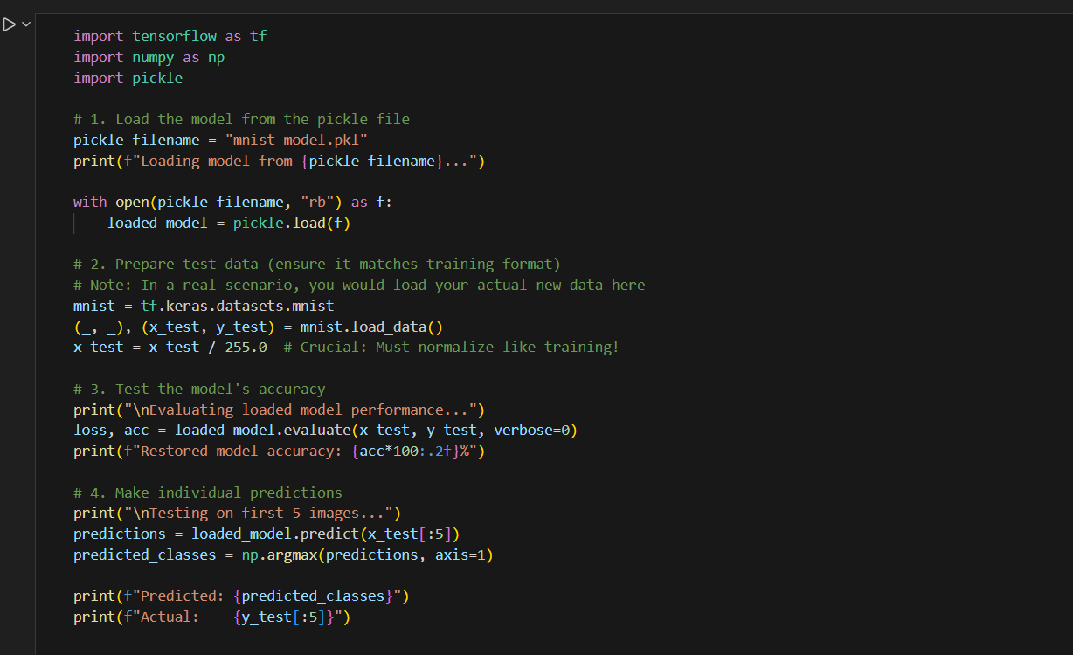

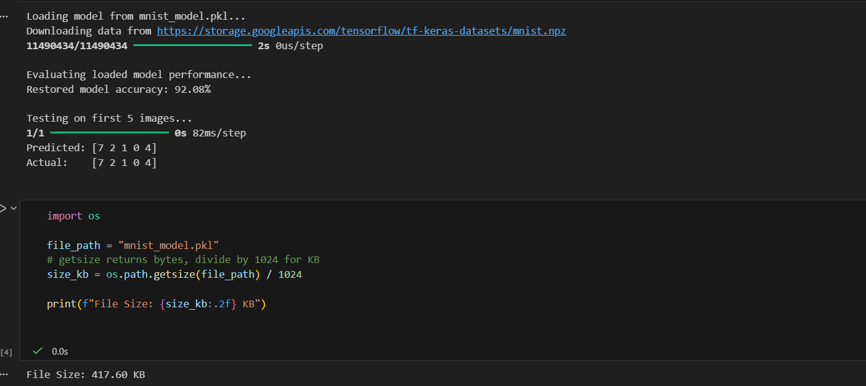

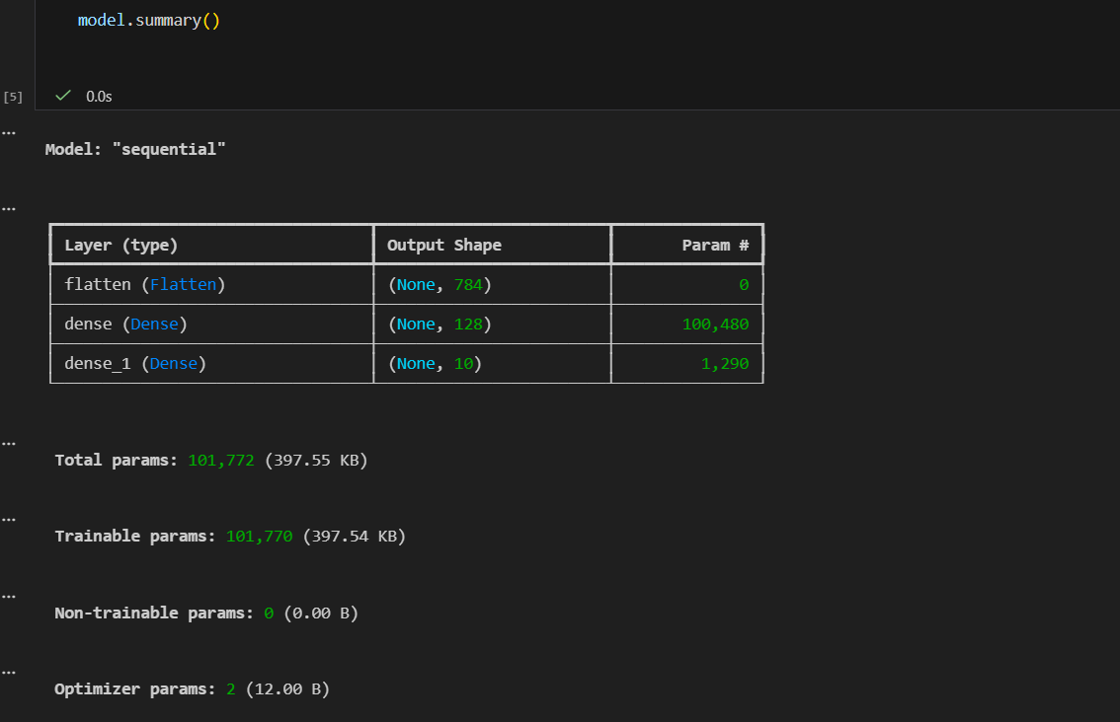

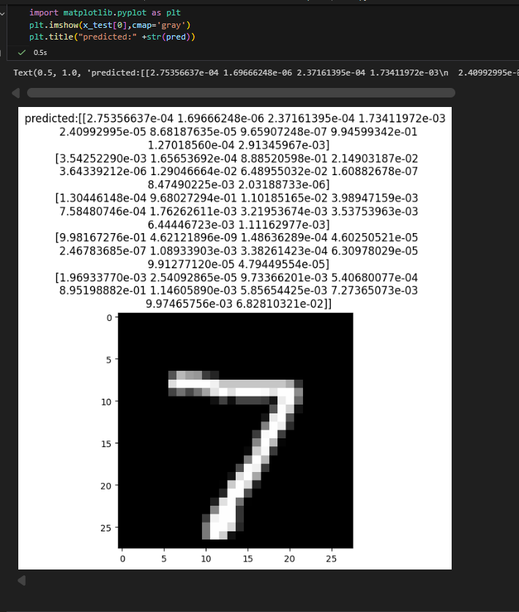

TASK 2: EDGE IMPLUSE

STEPS:
- Create an account on Edge Impulse.
- Login to the Edge Impulse platform.
- Create a new project.
- Click Data Acquisition.
- Select Connect to device.
- Choose Use mobile phone and scan the QR code.
- Connect the mobile phone as a camera.
- Capture sample images.
- Collect images for training and testing.
- Rename images with meaningful names.
- Label all images correctly.
Training -8
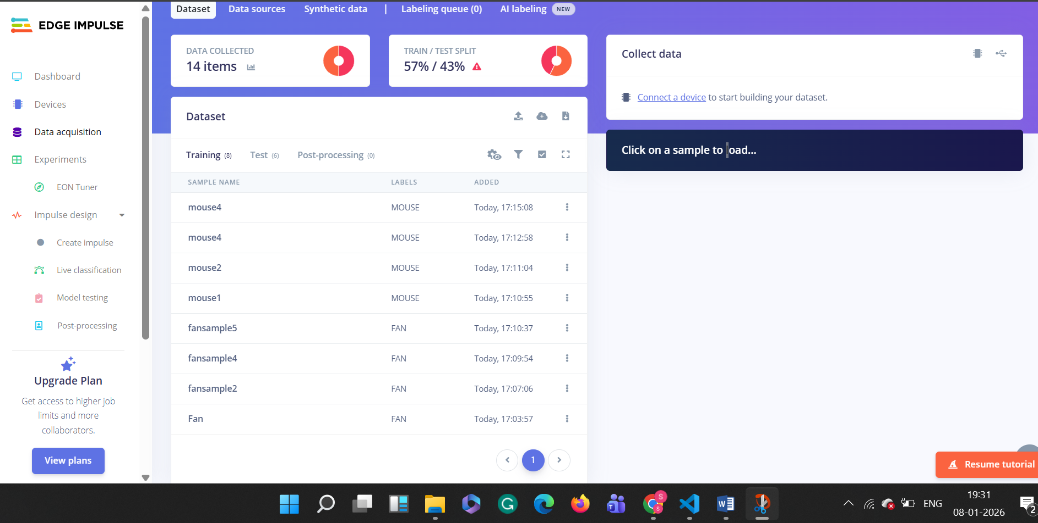

Testing-6
